Haseeb ullah f20232661009

**Example 4.1:**This program illustrates some arithmetic properties of integer (int) variables. Trace through the program to make sure you understand the values of each variable in all stages of the program.

|  |
| --- |
| #include <iostream>  using namespace std;  int main()  {  int a=4, b=0, c=0;  cout<<"a = "<<a<<" b = "<<b<<" c = "<<c<<endl;  b=6;  c=a+b;  cout<<"a = "<<a<<" b = "<<b<<" c = "<<c<<endl;  a++;  b -= 2;  --c;  b *= ++a;    cout<<"a = "<<a<<" b = "<<b<<" c = "<<c<<endl;  c /= a++; // how this become 100.  a = (b+c)*4;  c = b+c*4;  cout<<"a = "<<a<<" b = "<<b<<" c = "<<c<<endl;  return 0;  } |

**Output**

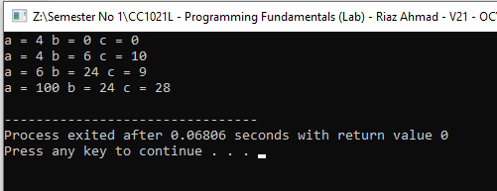

**Example 4.2:** Input a 3 digit value from the user (for example 521) and display it in reverse order (i.e. 125)

|  |
| --- |
| #include <iostream>  using namespace std;  int main() {  int number;  cout << "Enter a 3 number: ";  cin >> number;  int value1 = number % 10;  int value2 = (number / 10) % 10;  int value3 = number / 100;  cout << "Reversed: " << value1 << value2 << value3 << endl;  return 0;  } |

**Output**

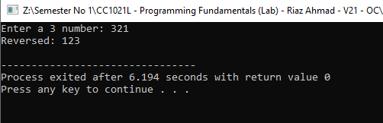

**Example 4.3:** Input the values for base and exponent and calculate its power using the pow(x,y) built in function.

|  |
| --- |
| #include <iostream>  #include <cmath>  using namespace std;  int main() {  double base, power;  cout << "Enter the base: ";  cin >> base;  cout << "Enter the power: ";  cin >> power;  double result = pow(base, power);  cout << "Result: " << result << endl;  return 0;  } |

**output**

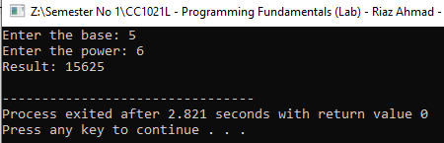

Lab exercise 1, 2 and 3

**Exercise 4.1:** Write a program that finds the area of a triangle given the length of its sides: a, b, c.

|  |
| --- |
| #include <iostream>  #include <cmath>  using namespace std;  int main() {  double g, h, i;  cout << "enter the length g: ";  cin >> g;  cout << "enter the length h: ";  cin >> h;  cout << "enter the length i: ";  cin >> i;  double s = (g + h + i) / 2;    double area = sqrt(s * (s - g) * (s - h) * (s - i));  cout << "the triangle area is: " << area << endl;    return 0;  } |

**OUTPUT**

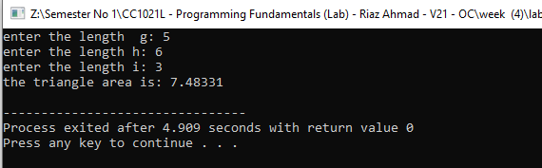

**Exercise 4.2:** Write a program taking two values as inputs from the user and display the results for all the basic arithmetic operations performed on them

Addition

Subtraction

Multiplication

Division

Modulus

|  |
| --- |
| #include <iostream>  using namespace std;  int main() {  double num1, num2;  cout << "Enter the first number: ";  cin >> num1;  cout << "Enter the second number: ";  cin >> num2;  cout << "Sum: " << (num1 + num2) << endl;  cout << "Difference: " << (num1 - num2) << endl;  cout << "Product: " << (num1 * num2) << endl;  if (num2 != 0) {  cout << "Division: " << (num1 / num2) << endl;  cout << "Modulus: " << ((int)num1) % ((int)num2) << endl;  } else {  cout << "Division by zero is undefined." << endl;  }  return 0;  } |

**Output**

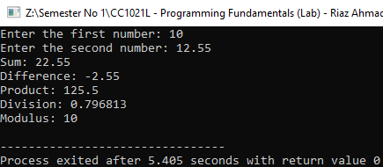

**Exercise 4.3:** Write a program that’s input 4 digit value from the user (for example 6382) and displays a result with an increment of 1 in each digit(ie. 7493)

|  |
| --- |
| #include <iostream>  using namespace std;  int main() {    int num;  cout << "Enter the the 4 digit number: ";  cin >> num;  num = num + 1111;    cout << "The 4 digits sum for each one is: "<< num << endl ;  if (num >= 1000 && num <= 9999){  num = num + 1111;  if(num > 9000){  num = num - 1000;  cout << "the incrment in each digit is: \n";  }  }else {  cout << "plz enter valid four digits numbers \n";  }    return 0;  } |

Output

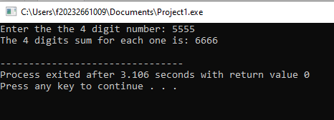

Home task 1 and 2

1. Write a program that takes any ASCII value from user and display next five char after that ASCII value.

|  |
| --- |
| #include <iostream>  using namespace std;  int main()  {  int ascivalue;  cout << "enter asci integer value: ";  cin >> ascivalue;    char ch = ++ascivalue;  cout << ch << " ";  ch = ++ascivalue;  cout << ch << " ";  ch = ++ascivalue;  ch = ++ascivalue;  cout << ch << " ";  ch = ++ascivalue;  cout << ch << " ";  ch = ++ascivalue;  cout << ch << " ";  ch = ++ascivalue;  return 0;  } |

Output

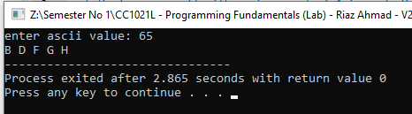

1. Write a program that raeds a four digit number from the user then the program separates digits of the number eg 4567 to be displayed as:

4

5

6

7

|  |
| --- |
| #include <iostream>  using namespace std;  int main() {    int number;  cout << "enter 4 digits numbers: ";    cin >> number;    int fourthdigit = number % 10;  int thirddigit = (number/10) % 10;  int seconddigit = (number / 100) % 10;  int firstdigit = number / 1000;    cout << firstdigit << endl;  cout << seconddigit << endl;  cout << thirddigit << endl;  cout << fourthdigit << endl;    return 0;  } |

Output

